The United Church Manse

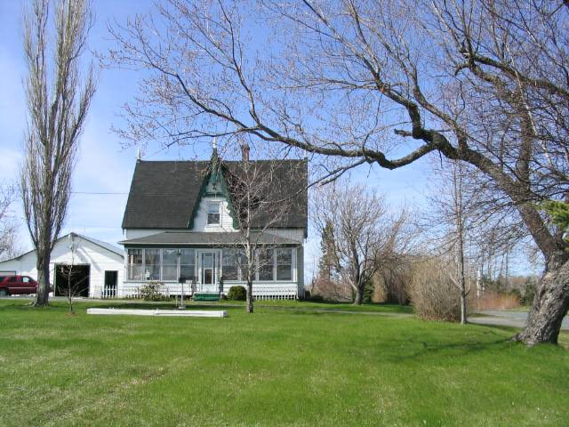
Photo by Glendenning on May 13, 2005

Although the nearby church was built in 1836, the manse was not constructed until 1880. In 19xx a new manse was constructed nearby and the original manse became the property of the Donnelly Family.

